* **Lab Task 5**

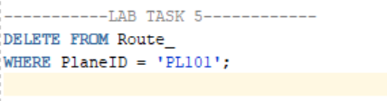Delete all the employees who work for Steven Kings

OUTPUT:

